AutoDoc – Intelligent API Documentation and Testing Assistant
Author: Vivek Pankantavita
Email: M25AI1062@IITJ.AC.IN
Course: Software & Data Engineering (SDE)
Year: 2025

1. Introduction
AutoDoc is a tool that automatically generates REST API documentation, OpenAPI specifications, and test cases from a FastAPI application.
Instead of writing documentation manually, AutoDoc scans the API code and creates all required documentation automatically.
The tool runs completely offline and does not require any external LLMs or API keys.

2. Problem Statement
Developers often forget to update API documentation, resulting in outdated, incomplete, or inconsistent docs.
Manual documentation also consumes time and introduces errors.
AutoDoc solves this by:
- Automatically extracting endpoints
- Reading methods and docstrings
- Generating documentation and test cases instantly

3. Project Objectives
- Extract API routes from FastAPI code.
- Generate Markdown documentation automatically.
- Create OpenAPI specification in JSON format.
- Suggest useful test cases for each endpoint.
- Produce human-like summaries using an offline pseudo-AI (rule-based).
- Maintain full offline functionality.

4. System Architecture
AutoDoc has three main components:
- sample_api.py
Contains the actual API endpoints (/hello, /hello/{name}, /echo).
- autodoc_core.py
Extracts routes and generates:
  - Markdown docs
  - OpenAPI JSON
  - Test cases
- ai_engine.py
Produces simple, human-like summaries using rules.
No AI keys or online services required

- run_autodoc.py
This file helps in running the project

5. Architecture Diagram
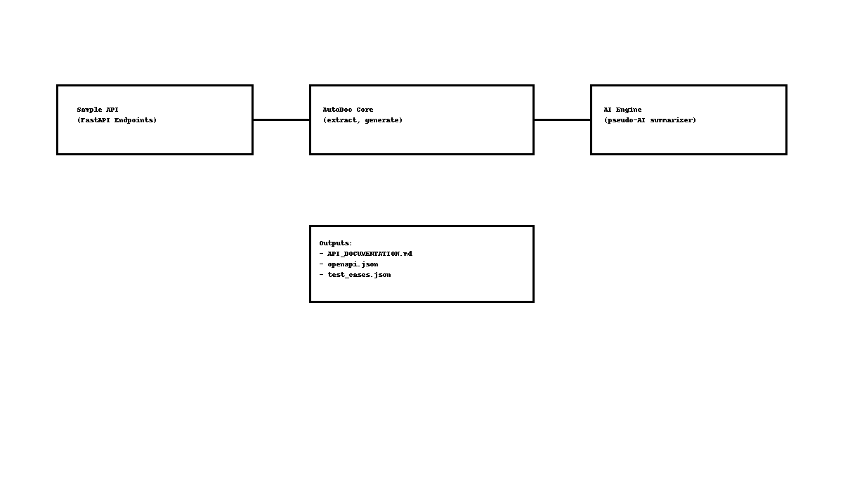

6. UML Class Diagram

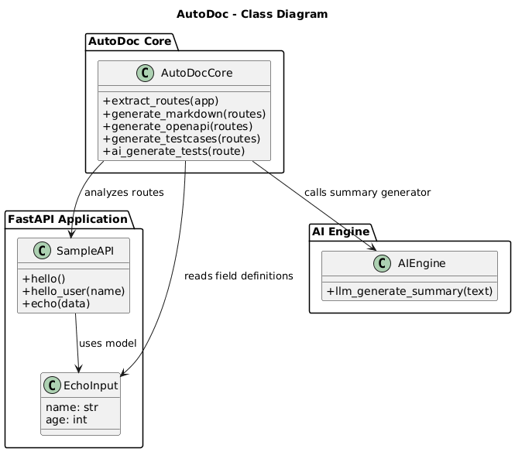

7. Implementation Details

7.1 Technologies Used
- Python 3.14
- FastAPI for route definition
- Custom pseudo-AI summarizer
- No cloud APIs or external LLM dependencies

8. Code Walkthrough

ai_engine.py
- Implements llm_generate_summary()
- Uses rule-based heuristics
- Provides AI-like description output without LLM

autodoc_core.py
- extract_routes() → Collects API metadata
- generate_markdown() → Creates API documentation
- generate_openapi() → Writes OpenAPI specification
- generate_testcases() → Suggests three core test scenarios per route

sample_api.py
- Contains two sample endpoints: /hello, hello/{name} and /echo
- Used to test AutoDoc functionality

run_autodoc.py
- Main runner script
- Generates all documentation files

Quality Attributes
This project focuses on three key software quality attributes:

1. Maintainability
AutoDoc is built using a modular architecture separating the extractor, generator, summarizer, and sample API. The codebase follows the Single Responsibility Principle and is easy to modify. Adding new API endpoints requires no change to the documentation codebase and is automatically reflected in the generated output. This reduces maintenance overhead and ensures long-term adaptability.

2. Reliability
AutoDoc is entirely offline and self-contained. Since it does not rely on external LLMs, network APIs, or cloud services, the output remains consistent across runs. The pseudo-AI summarizer is deterministic, and the tool generates identical documentation for identical code. This makes the system reliable and dependable even in restricted environments.

3. Usability
The tool is extremely easy to operate: a single command (python run_autodoc.py) generates complete documentation and test suggestions. The output formats (Markdown and JSON) follow industry conventions and are simple to consume. Users do not need to understand FastAPI internals—AutoDoc handles extraction automatically and produces clean human-readable documentation.

GIT Commits
a3085c9 (HEAD -> main, origin/main, origin/HEAD) Updated APi documentation
d3abbcc Updated autodoc core python file
0d9bb37 Updated sample api accordingly
dc70851 Updated test cases wit more data
797e396 Updated folder structure for better visibility
92ad7d3 Recommit clean repo without openapi secrets and documents
8ec028a removed all files
55a91da Initial commit - AutoDoc full commit
289d27a Initial commit

